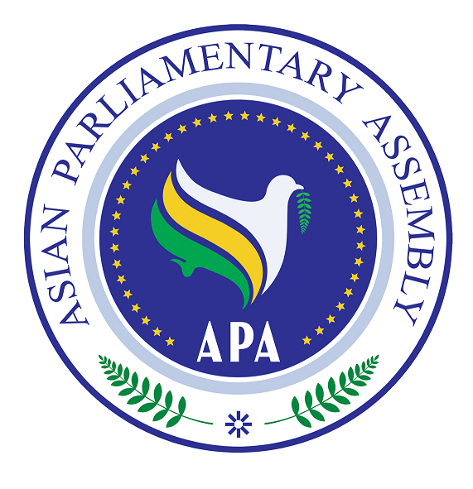

Asian Parliamentary assembly

SG/Rep/ 2009/11
6 November, 2009

Report of the Secretary General to the Ad-hoc Committee
on Financial Regulations

Background

In 29 November 2009, APA adopted the Resolution on APA Budget and Expenditure (APA/Res/2008/04) and encouraged the Secretary General to develop a set of financial regulations for consideration and approval of the Executive Council. The Secretary General submitted the draft Financial Regulations to the Executive Council meeting on 11 August 2009. The Executive Council decided to establish the Ad-hoc Committee on Financial Regulations to examine the said draft and make proper amendments and recommendations.

Financial Regulations

The present Financial Regulations (annex 1) sets the proper framework for the financial administration of the APA and facilitates and expedites its current activities. In these financial Regulations three important and interrelated aspects of APA’s administration and management have been under serious consideration:
- How to collect resources and funds under any category, including assessed contributions by Member Parliaments, voluntary contributions, donations, grants, interests and endowments.
- How to expend APA’s funds and resources in a transparent way based on adopted rules and regulations.
- How to ensure that the process of collecting and expending the APA’s fund is dealt with under the monitoring and scrutiny of a capable Financial Control Committee.

The draft before the Committee is prepared in light of the rules and regulations of regional and international organizations and based on the administrative needs of the APA. The Secretary- General has made some changes and modifications in the draft in order to better suite the financial activities of the APA. For example, it has been suggested that the fiscal year of APA runs from the first day of may to the last day of April in order to better enable Member Parliaments to pay their share in due time.

The Scale of the Assessed Contributions

On the scale of assessment of contributions by Member Parliaments to the Regular Budget of APA (annex 2), the Secretary-General reviewed the scale of payments in organizations such as OIC, UN, IPU, and proposed the scale that is more appropriate for APA. The proposed scale is mainly based on Member Parliaments’ share in IPU with minor modification and adjustment. In this proposal, Member Parliaments’ share in APA budget is divided into six categories which starts form 1% and ends up to 6%. Those who are paying up to 0.200% of IPU budget will pay 1% of APA budget and those who are paying more than 1% of IPU budget will pay 6%. The rest are in between.

Here I would like to affirm that subject to Rule 40 of the Rules of Procedure and pending the adoption of personnel regulations and payment of assessed contributions by Member Parliaments, the APA Budget is provided by the Host Parliaments of the Secretariat Headquarters in coordination with the APA President.

Grant and Voluntary Contributions

The Secretary General has taken various initiatives to promote the objectives of the APA through engagement of civil society, NGOs and private sectors. At the same time these endeavors have the capacity to secure funds and resources for APA. In this regard the Secretariat has received a proposal for holding three continent-wide forums on Asian Energy, Industry, economy and tourism. Successful managing of these Forums would enhance greater integration and cooperation in Asia as well as provide funds and financial resources for the APA.

At the end I should emphasize that the comprehensive and constructive deliberation on financial and administrative issues would enable the Secretariat to fulfill its obligations in a more active and successful manner and pave the way for greater cooperation and integration in Asia;

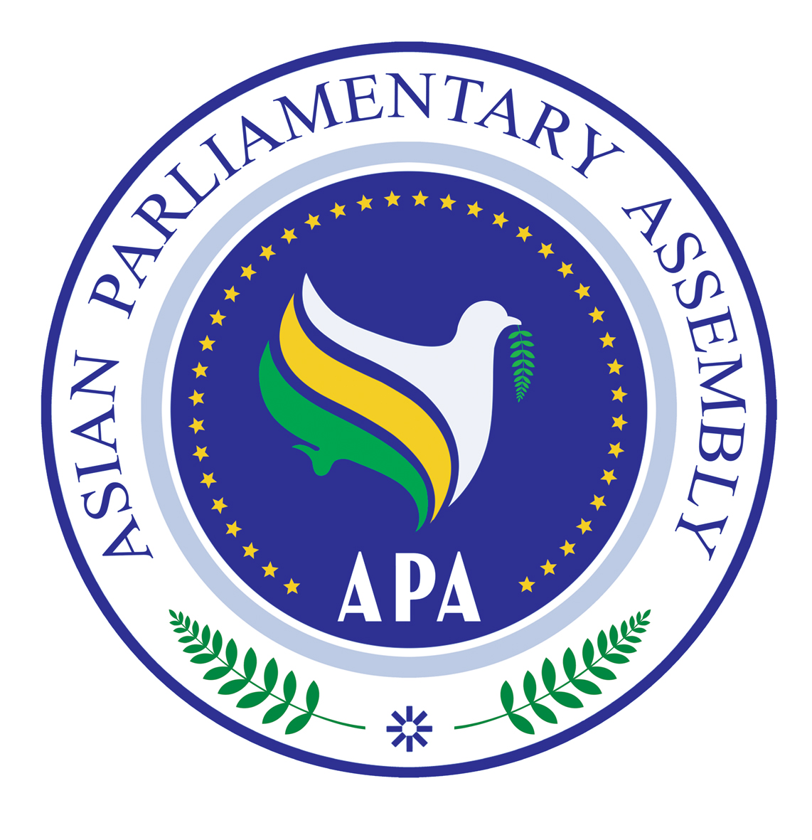

Asian Parliamentary Assembly
Secretariat

Annex - I
APA
FINANCIAL REGULATIONS

DRAFT

DRAFT
APA FINANCIAL REGULATIONS

ARTICLE -1

The present Financial Regulations organize the financial administration of the APA. The Regulations shall become effective once they are considered by the Executive Council and adopted by the Plenary. It may only be amended through a decision of two third majority of Member Parliaments present and voting in the plenary.

ARTICLE -2

The fiscal year shall run from the first day of May to the last day of April.

ARTICLE -3

Secretary General⁭ shall prepare and present the draft annual budget to the Member Parliaments at least 30 days in advance of the first meeting of the Executive Council. The Council may establish a committee for further consideration of the draft to formulate its recommendations on the draft budget to the Executive Council. The final budget shall be adopted by the Plenary not later than the end of the fiscal year.

ARTICLE -4

Any replacement, decrease or increase in any chapter of the budget by the Secretary General shall be acceptable within a limit of 20% thereof. If need be for a higher increase, the Secretary General shall present an explanatory note for the consideration of the Executive Council. Any new chapter may also be added to the budget to cover the expenses relating to any new activity, in which case, detailed explanatory information shall be provided by the Secretary General to the Executive Council for consideration.

ARTICLE -5

The budget and the Secretariat accounts shall be drawn up and kept in Euro and Iranian Rial.

ARTICLE -6

Upon approval of the budget by the Plenary, the Secretary General shall be authorized to undertake financial commitments for the purposes for which credits have been approved within the limits of such credits in each chapter and item.

ARTICLE -7

All payments to the APA under any category, including voluntary contribution by Member parliaments, donations, grants, endowments, interests granted to funds and deposits shall be made in Euro and maintained in APA bank accounts, so as to facilitate its international auditing.

ARTICLE- 8

8.1. APA Secretary General may transfer credits between items in any one chapter up to 20% of the budget within the limits of the credit approved for the chapter concerned.

8.2 The Secretary General may transfer credits between chapters of the budget; up to 20 % whenever needed within the limits of the credits for each of the chapters.

8.3 All such transfers shall be reported in the explanatory information referred to in Article 4, together with an explanation of the circumstances.

ARTICLE -9

Credits shall be used for commitments only during the fiscal year to which they relate. In case of non-payment or delay of contributions, and in order to meet the level of budget by the APA, the Secretary General is allowed to use the funds available and adjust accordingly.

ARTICLE - 10

10.1 The budget approved by the Plenary shall be financed by contributions from Member Parliaments which will be assessed on the basis of a formula to be considered by the Executive Council and adopted by the Plenary.

10.2 Subject to the Rule 40 of the Rules of Procedure, once the Plenary has approved the annual budget, the Secretary General shall advise Member Parliaments of their assessed contribution and request them to remit the funds.

10.3 Contributions shall be considered due and payable in full, within 90 days of the receipt by Member Parliaments of Secretary General’s letter of assessment.

10.4. Non-payment of contributions by any Member Parliament shall be reported to the Executive Council for appropriate decision, which may include reporting it to the Plenary.

10.5 The Secretary General shall submit to the Executive Council a report on the collection of contributions.

ARTICLE – 11

11.1. The Secretary General shall be responsible for administering the APA funds.

11.2. The Secretary General shall set up those internal controls as may be necessary to maintain a continuous check on all financial transactions, ensure fitness and transparency, prevent any misapplication of funds, and ensure the utmost economy.

11.3 To this end, the Secretary General shall issue directives, set procedures and take the following steps:

11.3.1 To check that all expenditure is in conformity with the credits and other fiscal measures approved by the Plenary.

11.3.2 To ensure that payments are made only on production of vouchers for services rendered and/or goods received.

11.3.3 To sign and seal, together with Head of Human and Financial Resources Department, all operations of transfer of funds or cheques and financial liabilities, payment orders or any other documents pertaining to expenditure from the budget.

ARTICLE -12

APA funds shall be kept in Banks of the APA Headquarters.

ARTICLE -13

13.1 The Head of Human and Financial Resources Department shall maintain documents to show:
13.1.1. Amounts authorized, commitments undertaken, payments made, and available balances of authorizations with respect to each item in the budget.

13.1.2 Assessed contributions of all Member Parliaments, together with the payments received from them and the balances remaining due.

13.1.3 Miscellaneous income.

13.1.4 Cash balances and balances at banks.

13.1.5 Other assets and liabilities of the APA.
13.2 The Secretary General shall present to the Executive Council biannual financial reports on the APA financial situation.

ARTICLE -14
The Secretary General is authorized to write-off on losses of cash, stores and other assets up to limit of 1000 Euro and anything above this amount has to be approved by the Executive Council. A full statement of all such amounts written off shall be attached to the annual financial report.

ARTICLE -15

The APA funds shall be made up of:

1- Payment of assessed contributions by Member Parliaments.
2- The grants, endowments and donations in cash and in kind accepted by the Secretary General⁭.
3- The Interests/profit granted on funds and deposits of the APA accounts.

ARTICLE -16

16.1 Upon the suggestion of Secretary General the Executive Council shall determine the fees of an External Account Auditor who shall be a certified accountant of the host country, locally appointed on a yearly basis by the Secretary General.

16.2 The local External Account Auditor shall present his/her report before the end of the fourth month of the next year to the Secretary General who shall submit it with his/her comments and views to the Financial Control Committee (FCC) , as defined by the paragraph 16.3 below, as well as to the Executive Council for consideration and approval.

16.3 A Financial Control Committee (FCC) composed of three Auditors shall be appointed by the Executive Council on a two-year rotational basis to be nominated by Member Parliaments from among those regularly contributing to the APA budget.

16.4 The Financial Control Committee (FCC) shall meet annually at the Headquarters of the Secretariat in order to audit the accounts of the Secretariat for the previous year and study the report made by the local External Auditor. The Committee shall present its report to the Executive Council through the Secretary General. This report shall include:

a) Remarks on financial matters.
b) An evaluation of the competence and efficiency of the appointed External Account Auditor.
c) Remarks on the report of the External Account Auditor.
d) The extent of effectiveness of the financial and internal control procedures within the Secretariat.

16.5 The local External Account Auditor shall abide by the conventional international rules and accounting standards.

16.6 In no case, however, shall the Financial Control Committee include substantial observations in its audit report without first affording the Secretary General or his/her representative(s) an opportunity for explanations to the FCC on the matter under observation. Such explanations shall be included in the report of the Committee.

16.7 The Secretary General may submit to the Executive Council a report giving his/her views and observations on the Report of the Financial Control Committee (FCC) and that of the local External Auditor.

16.8 The Secretary General shall pay the fees of the local External Account Auditor, while the fees and other expenses of the Financial Control Committee (FCC) shall be borne by their respective Parliaments.

16.9 No former staff member of the Secretariat shall be appointed as Auditor. Likewise, no former Auditor shall be appointed in the Secretariat before a period of three years has elapsed since he/she left his/her last position.

ARTICLE -17

The Executive Council shall examine the reports of the Financial Control Committee (FCC), of the local External Auditor and of the Secretary General. Approval of the Report of the Financial Control Committee (FCC) by the Executive Council shall authorize the closing of the accounts of the concerned fiscal year and clearing the Secretary General's financial responsibility thereon.

Annex – II
Draft proposal for the calculation of Assessed Contribution
of each Member Parliament in the APA budget
No | Country | Population | GDP/ Per Capita  PPP | % of IPU Budget | % of share Suggested by APA Secretariat
1 | Afghanistan | 27,000,000 | 758 | 0.181 | 1
2 | Bahrain | 750,000 | 34605 | 0.224 | 2
3 | Bangladesh | 159,000,000 | 1389 | 0.193 | 1
4 | Bhutan | 660,000 | 5238 | N/A | 1
5 | Cambodia | 14,000,000 | 2066 | 0.181 | 1
6 | China | 1,322,000,000 | 5963 | 1.651 | 6
7 | Cyprus | 800,000 | 29830 | 0.230 | 2
8 | India | 1,131,000,000 | 2762 | 0.652 | 5

2
No | Country | Population | GDP/ Per Capita  PPP | % of IPU Budget | % of share Suggested by APA Secretariat
9 | Indonesia | 232000000 | 3987 | 0.396 | 3
10 | Iran | 71,000,000 | 11250 | 0.793 | 5
11 | Iraq | 29,000,000 | 3479 | N/A | 2
12 | - Jordan | 6,000,000 | 5314 | 0.197 | 1
13 | Kazakhstan | 15,000,000 | 11416 | 0.396 | 3
14 | Kiribati | 98,000 | 6112 | N/A | 1
15 | DPR Korea | 24,000,000 | 1161  CIA | 0.212 | 2
16 | Republic of Korea | 48,512,000 | 27647 | 1.453 | 6
17 | Kuwait | 3,000,000 | 39850 | 0.461 | 4
18 | Kyrgyzstan | 5,000,000 | 2180 | 0.195 | 1

3
No | Country | Population | GDP/ Per Capita  PPP | % of IPU Budget | % of share Suggested by APA Secretariat
19 | - Laos | 6,000,000 | 2204 | 0.180 | 1
20 | Lebanon | 4,000,000 | 13032 | 0.220 | 2
21 | Malaysia | 28,000,000 | 14072 | 0.386 | 3
22 | - Maldives | 300,000 | 4951 | 0.180 | 1
23 | Mongolia | 2,600,000 | 3541 | 0.180 | 1
24 | Nepal | 28,196,000 | 1142 | 0.184 | 1
25 | Pakistan | 162000000 | 2739 | 0.264 | 2
26 | Palau | 20,000 | 7922  CIA | 0.180 | 1
27 | Palestinian Authority | 4,000,000 | N/A | N/A | 1
28 | Philippines | 89000000 | 3546 | 0.284 | 2

No | Country | Population | GDP/ Per Capita  PPP | % of IPU Budget | % of share Suggested by APA Secretariat
29 | Russia | 141,861,000 | 15922 | 4.528 | 6
30 | Saudi Arabia | 25,000,000 | 23834 | 1.153 | 6
31 | Singapore | 4,000,000 | 51142 | 0.480 | 4
32 | Sri Lanka | 19,000,000 | 4581 | 0.200 | 1
33 | Syria | 20,000,000 | 4749 | 0.222 | 2
34 | Tajikistan | 7,000,000 | 2019 | 0.187 | 1
35 | Thailand | 63,000,000 | 8225 | 0.376 | 3
36 | Tonga | 104,000 | 5373 | N/A | 1
37 | Turkey | 71,000,000 | 13138 | 0.574 | 5
38 | United Arab Emirates | 4,000,000 | 38830 | 0.491 | 4
39 | Uzbekistan | 27,372,000 | 2630 | N/A | 2
4

No | Country | Population | GDP/ Per Capita  PPP | % of IPU Budget | % of share Suggested by APA Secretariat
40 | Vietnam | 87,000,000 | 2784 | 0.208 | 2
41 | Yemen | 21,000,000 | 2412 | 0.191 | 1
5

Assumptions:
The items which affect the share of Member Parliaments in the APA budget are:
- Population, GDP/per capita/ PPP [The value of all final goods and services produced within a nation in a given year divided by the average population for the same year. GDP/PPP/Per Capita is based on International Monetary Fund (IMF) statistics in 2008].
- Minimum share in APA Budget is 1 %
- Maximum Share in APA Budget is 6%
- The share of Member Parliaments in the IPU budget
Considering the fact that IPU is a Parliamentary organization, share of APA Member Parliaments in the IPU budget is the most acceptable scale to determine their share in the APA budget. Broad distribution of percentage of the shares in IPU budget, leads the Secretariat to prefer the following scale:
- Member Parliaments paying up to 0.200 % of IPU Budget = Will pay 1% of APA Budget
- Member Parliaments paying up to 0.300 % of IPU Budget = Will pay 2% of APA Budget
- Member Parliaments paying up to 0.400 % of IPU Budget = Will pay 3.0% of APA Budget
- Member Parliaments paying up to 0.500 % of IPU Budget = Will pay 4.0% of APA Budget
- Member Parliaments paying up to 1% of IPU Budget = Will pay 5.0% of APA Budget
- Member Parliaments paying more than 1 % of IPU Budget = Will pay 6% of APA Budget
- Those Member Parliaments that their share in IPU Budget is not available, their share in APA Budget is calculated according to their P/C GDP
Notice: The APA Secretary General has proposed a proposal for establishing the Forum of Asia, through the cooperation of leading Asian businesses, companies, Institutes … and the APA budget could be raised totally from its share in the net benefits of the Forum.

